- Install git.
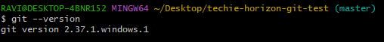
- Create a repo in github with README.md and .ignore file.
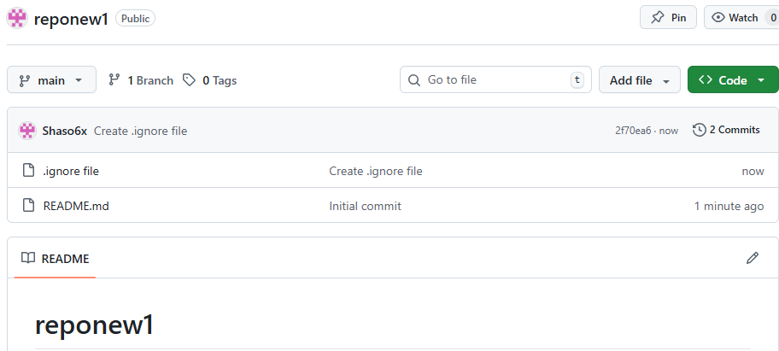
- Clone the created repo to local.
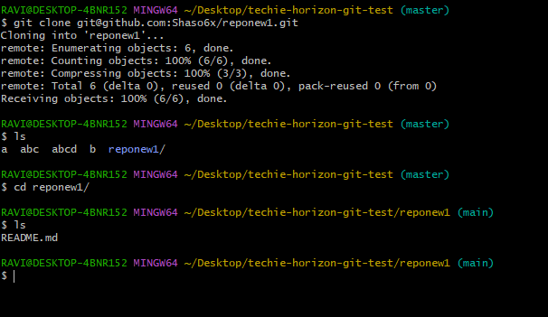
- Create two files in local repo.
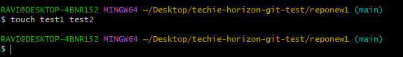
- Commit two files and push to central Repository.
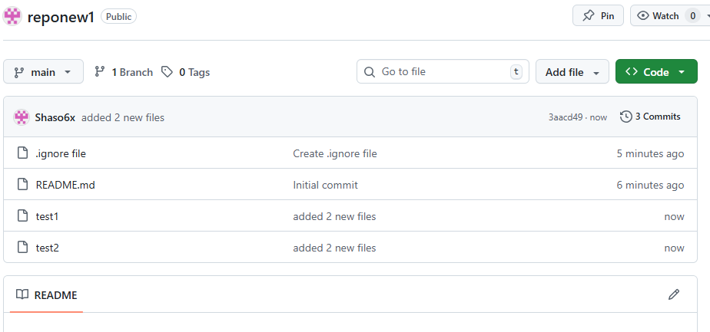
- Create a branch in local and create a sample file and push to central.
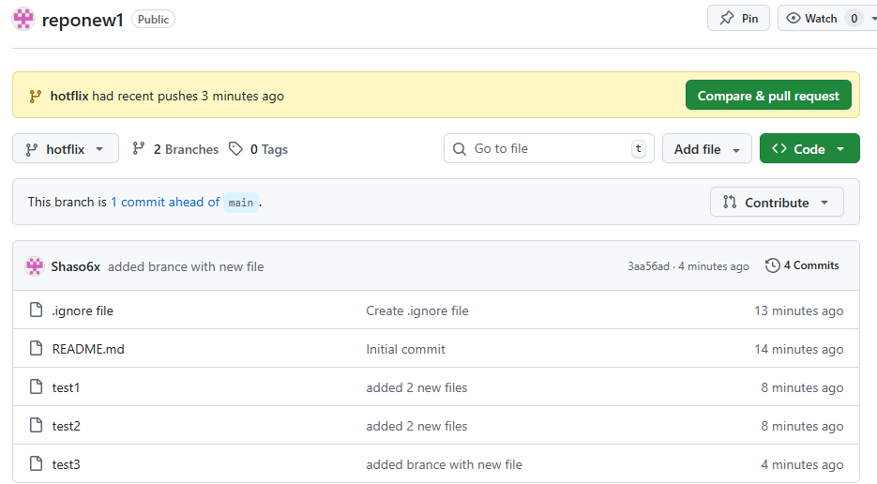
- Create a branch in github and clone that to local.
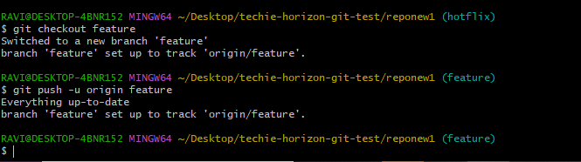

- Merge the created branch with master in git local.
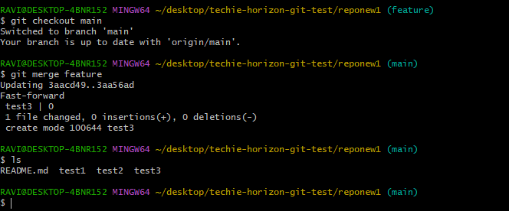

- Merge the created branch with master in github by sending a pull request.
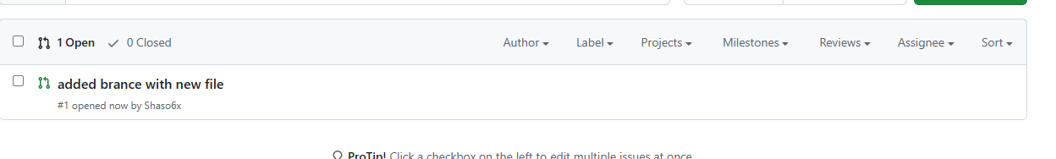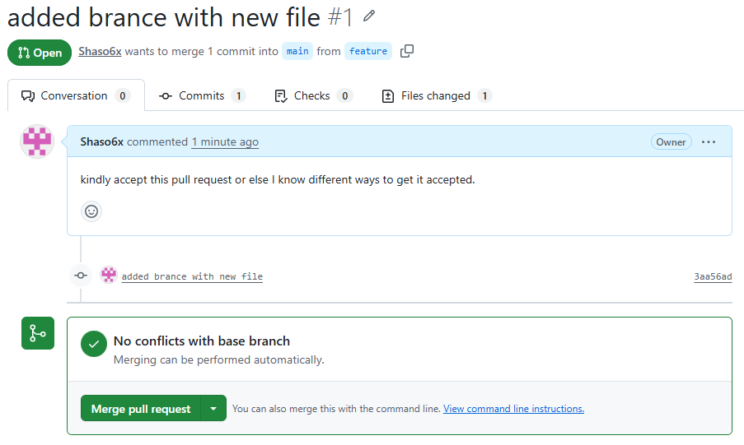

- Create a file in local and send that to branch in github.
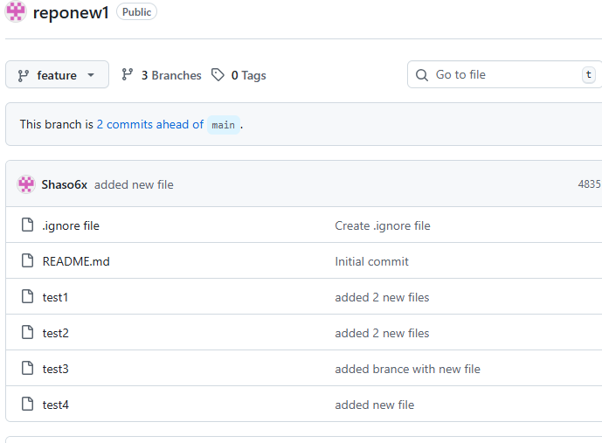
- Clone only a branch from github to local.
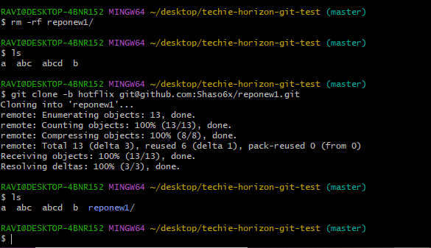

- Create a file with all passwords and make that untrackable with git.
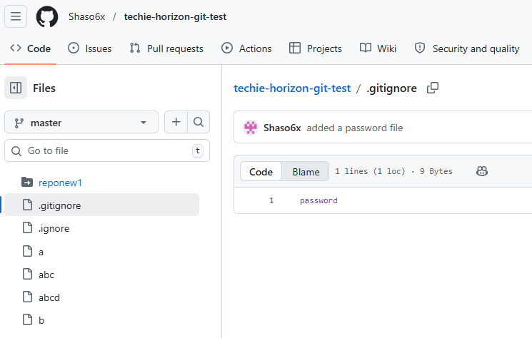
- Make a commit and make that commit reset without savings changes.
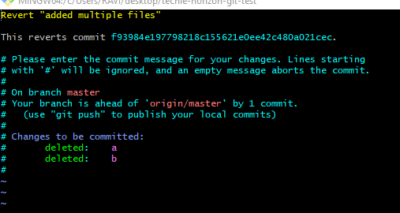
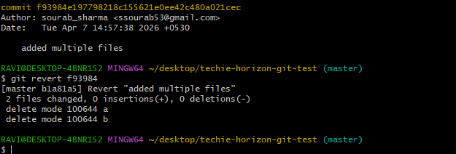
- Revert a commited commit to the older version.
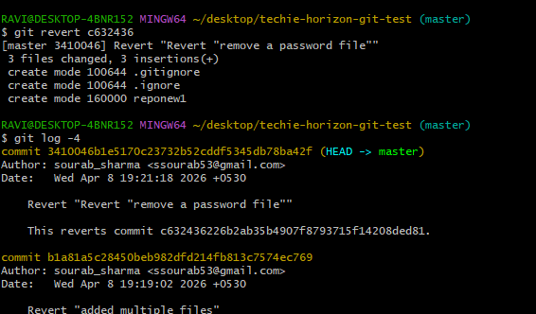

- Push a file to stash without savings the changes and work on another file.
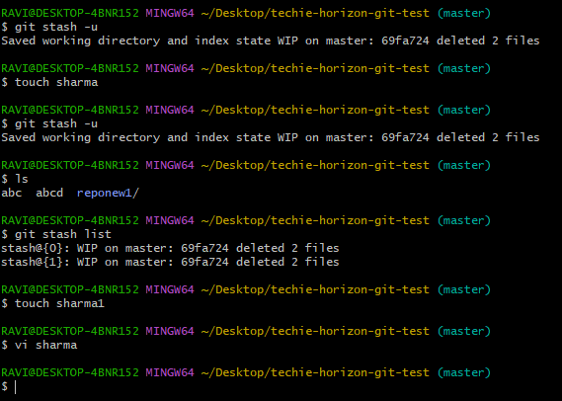
- Undo the stash file and start working on that again.
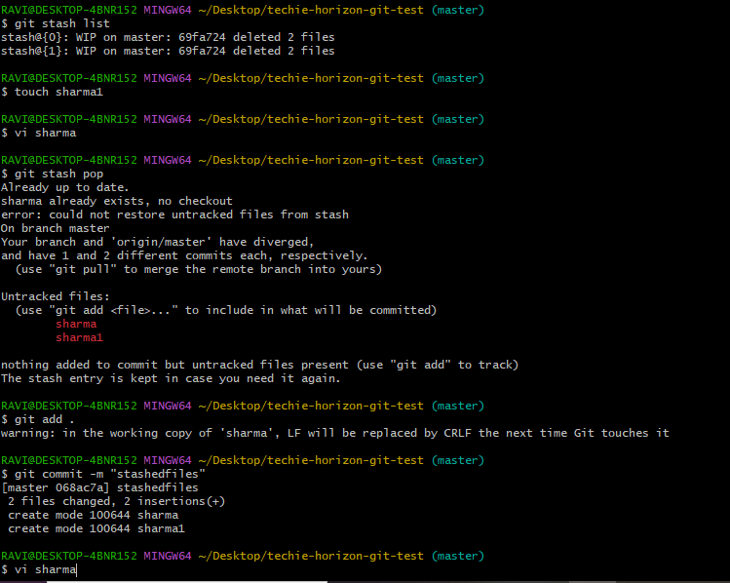
- Generate a ssh-keygen and configure into github.
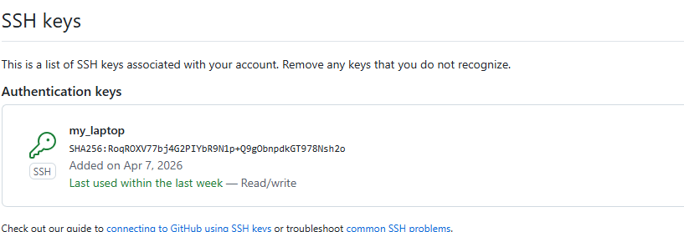
- Configure webhooks to github.
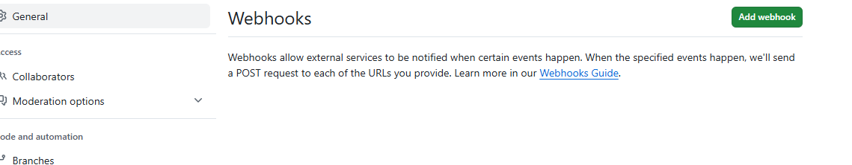
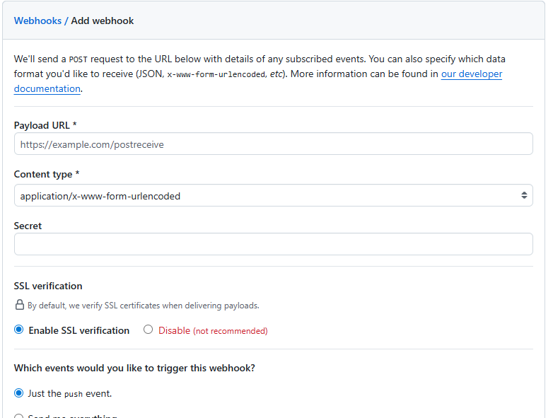

- Basic understanding of .git file.
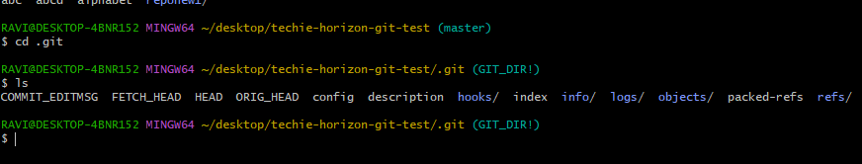

- Check all the logs of git.
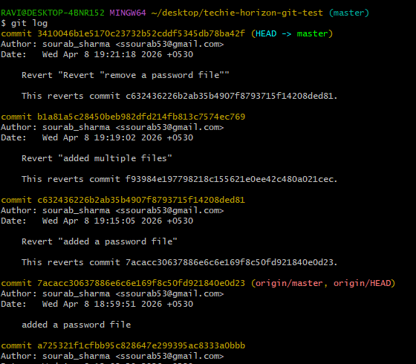
- Rename the commit message.
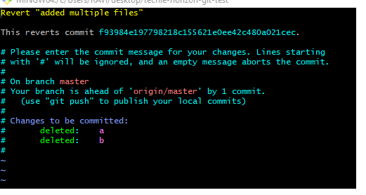

- Merge multiple commits into single commit.
